Name: |  | Date:
 | Year 7 Mathematics  Term 3, 2021  Test: Algebra and Graphing  Resources Allowed:  - 1 piece A4 paper notes  - Pens, pencils, ruler | Total Marks:

Question 1 (4 marks)
Use the following words to complete the sentences below.

equation, LHS (left hand side), expression, RHS (right hand side)

- An ______________________ is a collection of pronumerals, numbers and operators without an equal sign.
- An ______________________ is a mathematical statement stating that two things are equal.
- Equations have a __________________ and a __________________ and equals sign in between.

Question 2 (4 marks)
Draw a line to match the statements in their simplest form.
- 4 more than k 4m
- 4 lots of m y - 7
- Y decreased by 7 4 + k
- The product of 5 and the result of the sum of 4 and double x 5(4 + 2x)

Question 3 (4 marks)
Simplify the following by collecting like terms:
- 3b + 7b + 4 _______________________
- 4x + x – 2x + 2y _______________________
- 3 + 6xy + 3xy – 2 _______________________
- 7a + 4a + b + b + a _______________________

Question 4 (4 marks)
- If a = 5 and b = 4, what is the value of 3a + 2b?

- If x = 2, what is the value of 4x + 7?

Question 5 (6 marks)
Solve each of the following equations. (show all working)
- a – 3 = 7 | - 5d – 4 = 46
- 3 + (x-6) = 5 | - 35 = 7c

Question 6 (6 marks)
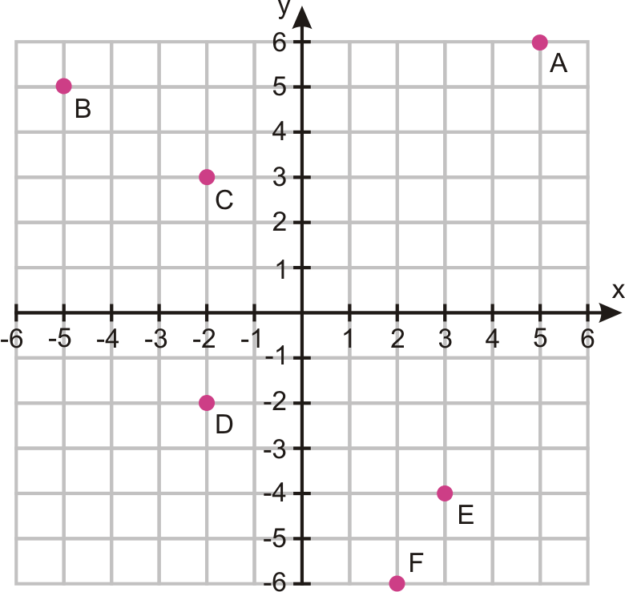
Identify the points of the coordinate plane below.

A: ____________________________
B: ____________________________
C: ____________________________
D: ____________________________
E: ____________________________
F: ____________________________

Question 7 (2 marks)
Using the table of values below, plot the points on the graph and draw a line through the points.
Y = 2x + 1
X | 1 | 2 | 3 | 4 | 5
Y | 3 | 5 | 7 | 9 | 11
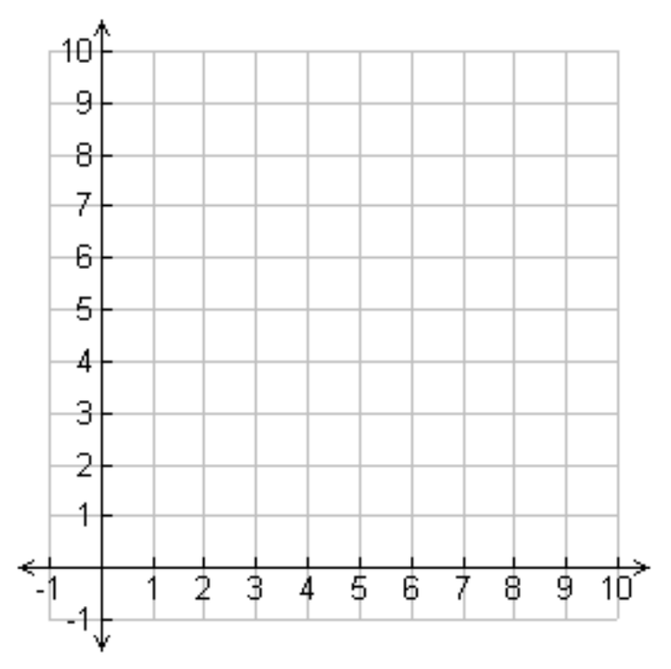

Question 8 (4 marks)
Fill in the missing numbers from the table of values using the rule below.
Y = 2m + 4
X | 1 | 2 | 3 | 4 | 5
Y

Using the table of values, plot the points on the graph and draw a line through the points.
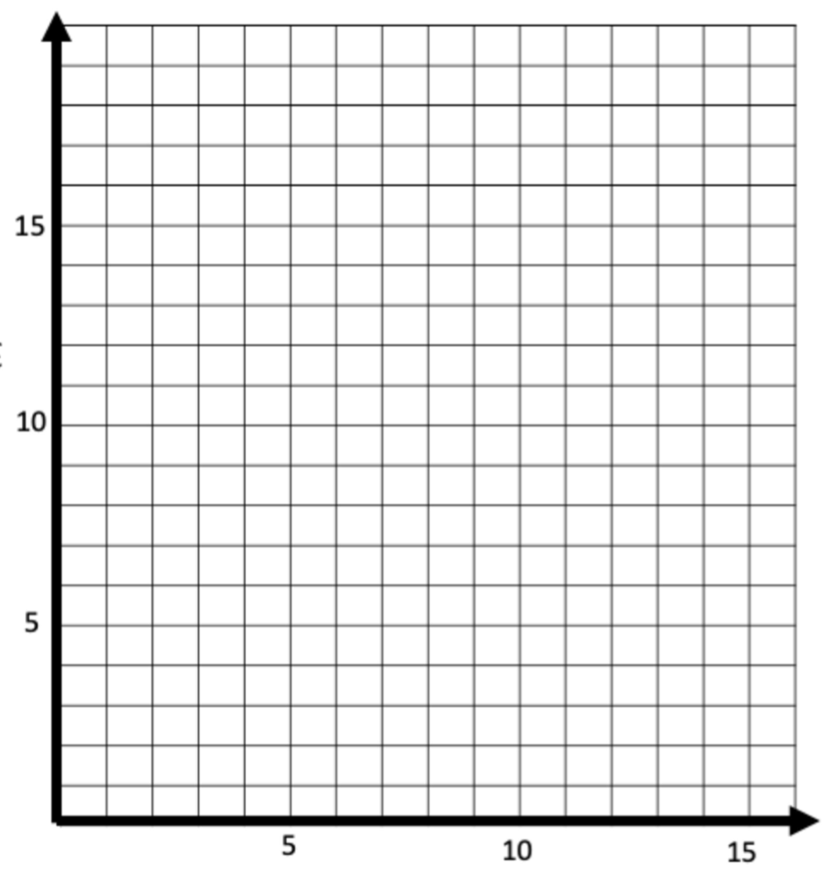

End of test

